Encouraging employers to be more flexible with staff working hours under certain conditions

Health and wellbeing for employees

Reduction in carbon footprint

Improved productivity

1. PROBLEM: With traffic congestion leading to an average personal commute time of 53 minutes daily (ref), this has an impact on:

Individuals with increased stress levels of individuals and families

significant cost to business

a high carbon footprint

high loads on Victoria’s traffic network.

SOLUTION: The utilisation of live Vic Roads traffic data and Bureau of Meteorology forecasts and live weather data allows probabilistic recognition of potential traffic hot spots due to weather events and other weather related emergency incidents, during peak and non-peak road usage periods. This real time ongoing analysis of historical vs real-time traffic flows can also be utilised to encourage people to not travel during weather events, to travel outside of peak times if possible, or to recommend a variation to travel routes.

1. HISTORICAL SAMPLE OF THE PROBLEM: Olympic Park grid, good weather vs some rain and corresponding timings on Punt Road.

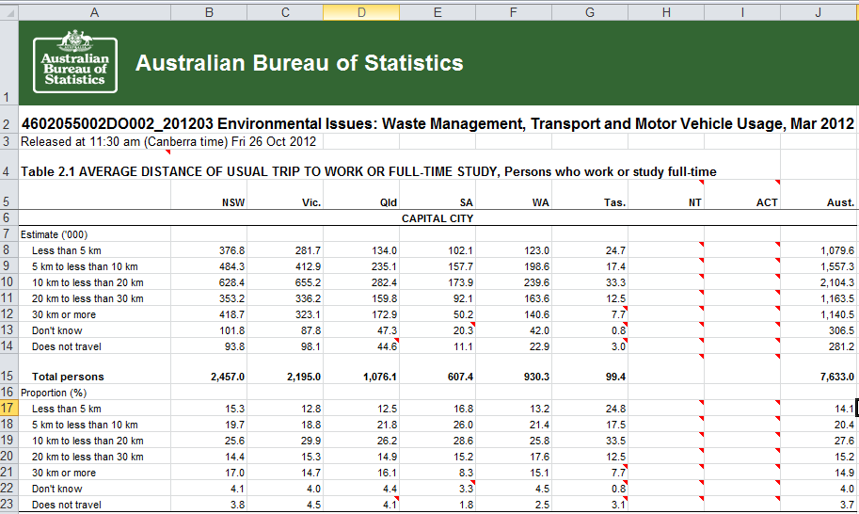

|  |  |
| --- | --- |
| **Dataset Name** | **URL** |
| Traffic Volumes for Freeways and Arterial Roads - Victorian Government Data Directory | <http://data.vicroads.vic.gov.au/metadata/filesvicroadsvicdatalatestmmwspeeddatabyroadsegment.html> |
| BlueTooth Data (GovHack 2017) - Victorian Government Data Directory | http://data.vicroads.vic.gov.au/Metadata/BlueTooth_Data.html |
|  |  |
| Road Works and Events Live - Lines (GovHack 2017) - Victorian Government Data Directory | <http://data.vicroads.vic.gov.au/metadata/Road_Works_Events_Points_Live.html> |
| Grid Forecasts API | https://api.cloud.bom.gov.au/forecasts/v1/grid |
|  |  |

**How datasets were used:**

**Traffic Volumes for Freeways and Arterial Roads - Victorian Government Data Directory**

This data was used to initially assess speed data for individual roads over various periods of time throughout a day. It was used to confirm peak traffic times and variation of average speeds between peak and non-peak periods. (See screen shot example)

**BlueTooth Data (GovHack 2017) - Victorian Government Data Directory**

This small snapshot of historical data from June 2017 was used to verify specific travel times along sections of road and how those specific travel times varied throughout the interested timeslots. It is proposed that ongoing recording of this data would enable effective monitoring and prediction of traffic flows, taking into account the impact of weather related events, rainfall, etc

Using the Real-time Bluetooth API, it would further build this dataset, looking for variation of traffic speeds outside of normal patterns, as well as variation based on forecast and actual weather conditions using the Bureau of Meteorology Grid forecasts API.

There is potential to expand this measurement to include further roads outside of the existing Bluetooth network by using Google APIs, but this have limitations in comparison between live and historical data.

**Road Works and Events Live - Lines (GovHack 2017) - Victorian Government Data Directory**

This API has not been used directly in the analysis applied. It should be noted however, that road works and events should be excluded from longer term results being used to determine reasonable averages for traffic times and road speed, unless the road works or events are still in place and intended to remain in place for some time. This will ensure that the corresponding averages are not moved in a way which prevents the effective representation of current travel times compared to those historical averages.

**Grid Forecasts API - Bureau of Meteorology (BOM)**

The publicly available rainfall dataset (see screenshot/table) was used to compare traffic times for a specific day for which we had a Bluetooth traffic dataset available (Jun 29th and June 30th - rain impacted days).

Going forward, it is proposed to utilise the Grid Forecasts API, which provides forecasts at 3hr intervals over a 6 day period. This API data can then highlight when further potential traffic delays and congestion is expected due to weather, enabling further automated routing of traffic based on predictive data analysis.

Traffic picture – congestion

Grumpy driver with poor health and wellbeing (maybe business?) – bring back to awards

Snapshot – of traffic data from ABS

Proof of slow traffic in peak hr / bad weather

Encourage businesses to allow staff to be more flexible in staff start and finish times

Staff opt in to an App for flex start and finish times

Show how the AI closed feedback loop assesses the probability of traffic volumes being excessive

Example – the night before or on the morning of a day of travel:

Notification is sent to staff members about optimised travel times for the day, within user defined thresholds

On the day:

Vicroads traffic management continually re-assessing and optimising traffic flow based on predicted flows determined by actual historics flows compared to actual historic weather data corresponding 3 hr forecasts.

For Vic Roads – improved traffic flow and management (show how vehicles per hr metric improved)

For the Individual – better health and wellbeing and better use of their time (bring back to awards)

For the enterprise – better productivity and less impact to their business.